

Report

on

**BidNEvent**

Submitted By: Submitted To:

Arpita Chauhan - B - 2115000204 Mr. Abhishek Kr Tiwari

Divya Singh - C - 2115000375 Technical Trainer

Shradha Saxena - C - 2115000966 CEA

Swapnil Peeyoush Gupta - D - 2115001026

**INDEX**

|  |  |  |
| --- | --- | --- |
| **S. NO.** | **TITLE** | **Page No.** |
| 1 | Title and abstract | 1 |
| 2 | Introduction | 2-4 |
| 3 | Objective | 5 |
| 4 | Scope | 6 |
| 5 | Methodology | 7 |
| 6 | System design and architecture | 8-10 |
| 7 | Implementation Plan | 11-12 |
| 8 | Testing and quality assurance | 13 |
| 9 | Result and findings | 14 |
| 10 | Conclusion | 15 |
| 11 | Future Work | 16 |
| 12 | Sources | 17 |

**Title:**

BidNEvent

**Abstract:**

Bidnevent is an innovative event management platform designed to streamline and revolutionize the way events are planned and executed. Developed using cutting-edge technologies such as Node.js, MongoDB, HTML, and CSS, Bidnevent offers a transparent marketplace where event organizers can seamlessly connect with vendors. This platform introduces a competitive bidding system, promoting fair competition among vendors and empowering organizers to create unique events within their vision and budget. With a user-friendly interface, real-time updates, and secure payment gateways, Bidnevent provides a comprehensive and enjoyable user experience. Initial results indicate rapid user adoption, positive feedback on bidding dynamics, and the successful showcase of innovative event planning. Bidnevent stands poised for future growth and continued innovation in the dynamic landscape of event management.

**Introduction:**

Welcome to Bidnevent, your gateway to a revolutionized event management experience. This innovative platform is designed to streamline event planning, connecting organizers with vendors seamlessly. Bidnevent, powered by cutting-edge technologies, offers a transparent marketplace where vendors bid competitively, empowering organizers to create unique events within their vision and budget. Join us as we redefine event management—where every event is an opportunity for creativity, efficiency, and excellence.

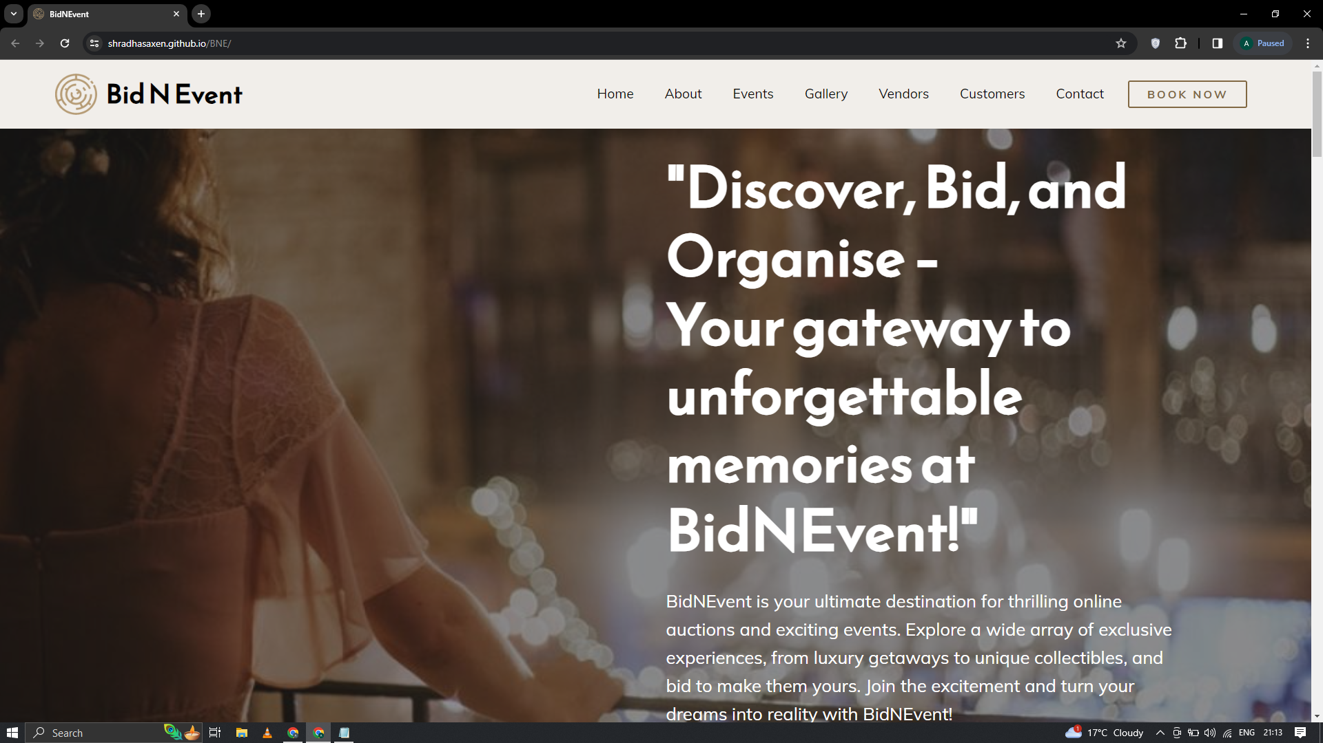

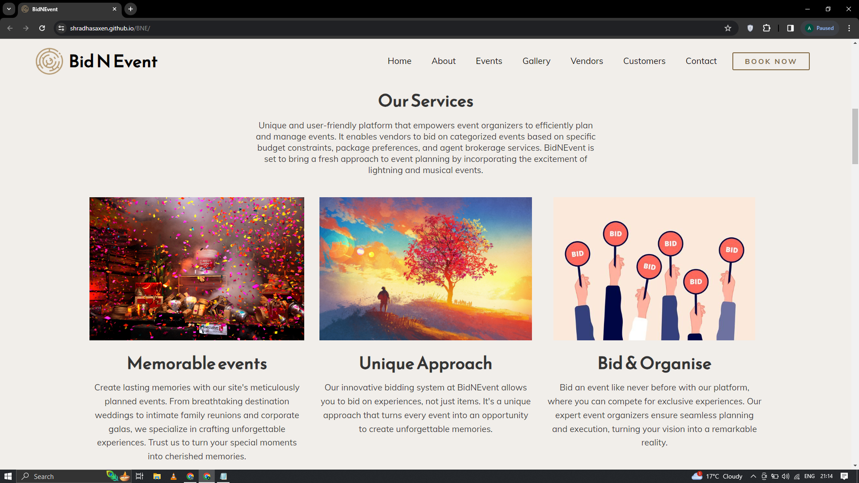

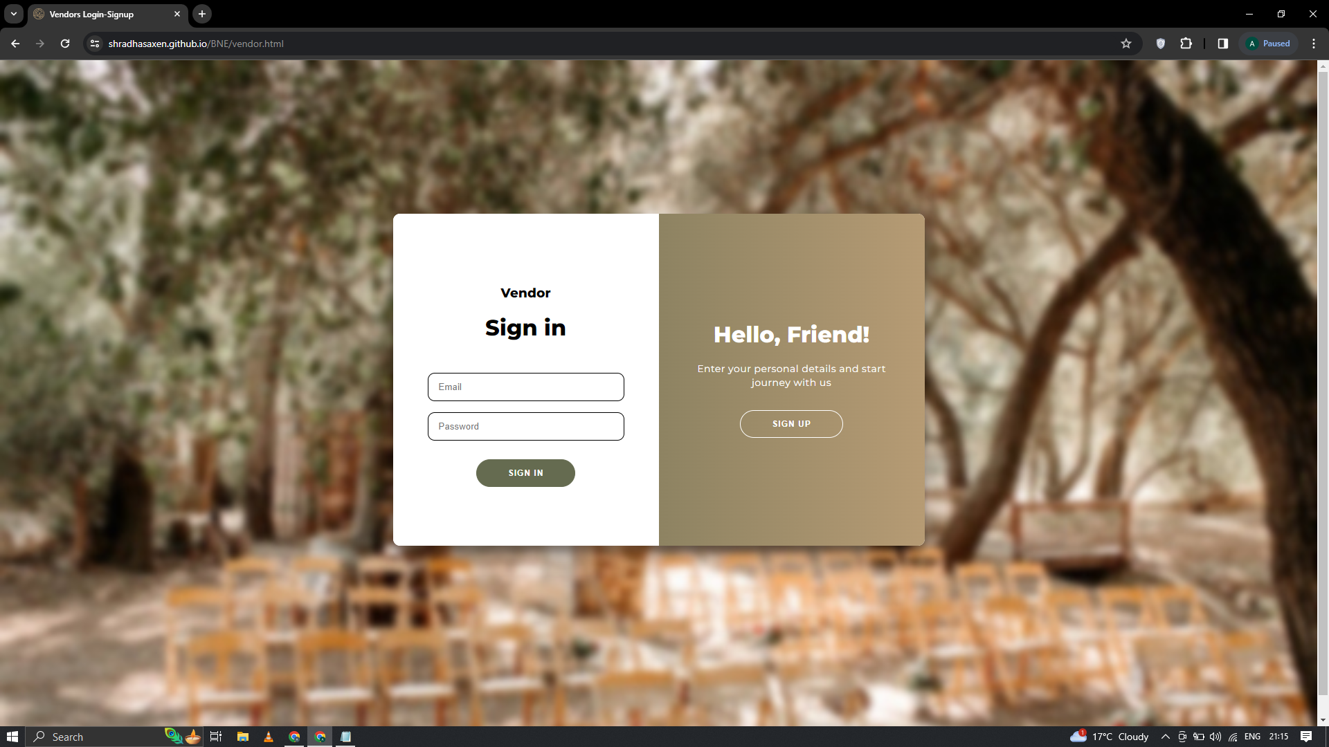

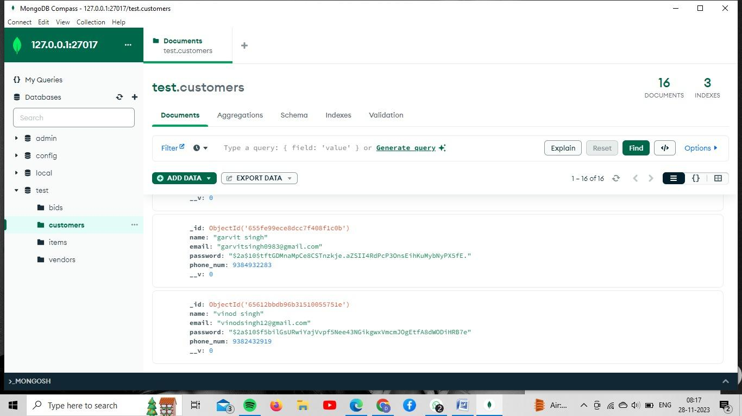

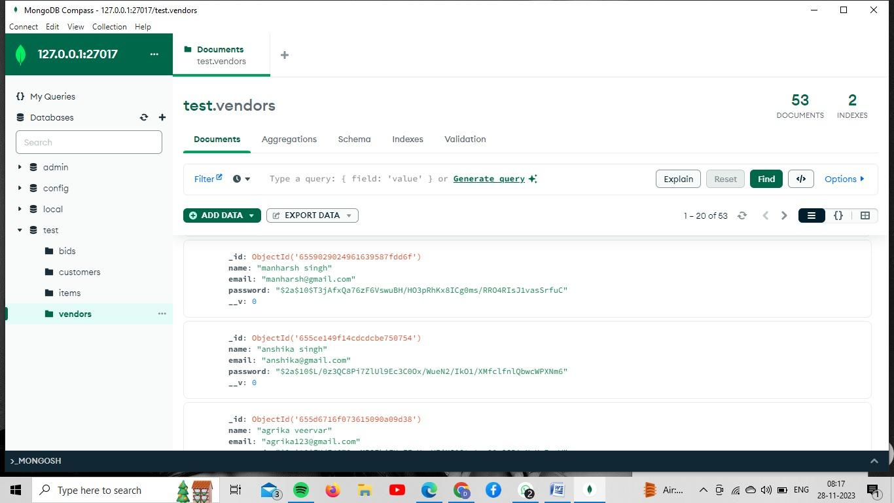

**Objective:**

Create a unique ecommerce platform for event management allowing vendors to publish their services on categorized events on specific budget, package type and agent brokerage with a spark of lightning and musical events and allowing customers to avail those services.

The primary objective of Bidnevent is to revolutionize the event management industry by creating an innovative e-commerce platform. This platform aims to seamlessly connect event organizers with vendors, providing a transparent and efficient marketplace. The core goal is to develop a user-friendly interface using HTML and CSS, coupled with real-time updates through Node.js, ensuring a positive and intuitive user experience. Establish a transparent marketplace where vendors can competitively bid on listed events, promoting fair competition and diverse offerings. Provide a platform that serves as a showcase for innovative event planning, encouraging unique and memorable events. Bidnevent's objective is to redefine the event management experience, making it more accessible, efficient, and creative for both event organizers and vendors.

**Scope:**

Bidnevent is a pioneering e-commerce platform designed to revolutionize the world of event management. The project's main goal is to create a unique and user-friendly platform that empowers event organizers to efficiently plan and manage events. It enables vendors to bid on categorized events based on specific budget constraints, package preferences, and agent brokerage services. Bidnevent is set to bring a fresh approach to event planning by incorporating the excitement of lightning and musical events. Our project is limited to the local area people of Mathura. Our project’s scope is to help people organize events remotely.

**Methodology:**

Node JS - Used for connecting frontend with the database and server.

MongoDB - Used for storing data for all the authentic users and vendors and storing the item details for selling and bidding.

HTML - Used for the structure of the website, it gives an interface to our website

CSS - Used to define styles for the web pages, including the design, layout and variations in display for different devices and screen sizes.

**System design and architecture:**

1. Frontend:

Developed using HTML and CSS for a sleek and responsive user interface.

Ensures an intuitive and enjoyable experience for users.

2. Backend:

Utilizes Node.js for server-side development, providing real-time updates and seamless interactions. Empowers the platform with scalability and responsiveness.

3. Database:

MongoDB is chosen as the backend database for efficient data storage and retrieval.

Manages user profiles, event data, and vendor information.

4. User Authentication:

Implements secure user registration and authentication mechanisms.

Ensures a safe and personalized experience for each user.

5. Event Categorization:

Categorizes events systematically for easy navigation and selection.

6. Vendor Management:

Allows vendors to register, create profiles, and showcase services.

7. Real-Time Updates:

Node.js facilitates real-time updates. Enhances user engagement and communication.

8. Event Listing and Bidding:

Enables event organizers to list events with details, budgets, and preferences.

Vendors can competitively bid, promoting fair competition.

9. Security Measures:

Implements robust security measures to protect user data and ensure platform integrity.

Passwords are saved with salt attached to it so that even if the data gets stolen, no one can access the password.

10. Responsive Design:

Designs the platform with a responsive layout for accessibility on various devices.

11. Scalability:

Built with scalability in mind to accommodate a growing user base and expanding event listings.

In summary, Bidnevent's system design and architecture combine a user-friendly frontend, a dynamic and responsive backend, and a secure, efficient database to create a seamless and innovative event management platform.

**Implementation Plan:**

* **Requirements Gathering:**

Define the specific requirements and features of Bidnevent.

* **Technology Selection:**

Choose the technology stack: Node.js for server-side, MongoDB for the database, and HTML/CSS for frontend development.

* **System Design:**

Create detailed system architecture, database schema, and user interface designs.

* **Database Setup:**

Set up and configure MongoDB as the backend database.

* **Backend Development:**

Develop the server-side components using Node.js, including user management, event listing, and vendor management.

* **Frontend Development:**

Create the user interface using HTML and CSS, incorporating responsive design principles.

* **User Registration and Authentication:**

Implement user registration and authentication features.

* **Event Listing and Bidding:**

Develop the core functionality for event listing and vendor bidding.

* **Real-Time Features:**

Integrate Node.js for real-time updates, notifications, and instant messaging.

* **Testing:**

Conduct extensive testing, including functional, usability, security, and performance testing.

* **Deployment:**

Deploy the platform on a web server, ensuring scalability and high availability.

* **User Feedback:**

Collect user feedback and make necessary improvements to enhance the platform.

This concise implementation plan outlines the key steps and milestones for developing and launching the Bidnevent platform, ensuring a well-structured and successful project.

**Testing and quality assurance:**

Comprehensive Testing: Rigorous testing including functional, usability, security, and performance testing to ensure platform reliability.

User Feedback Integration: Collecting and implementing user feedback for continual improvement and optimization.

Security Measures: Regular updates and enhancements to security protocols to safeguard user data.

Scalability Testing: Ensuring the platform can handle growth by testing scalability and performance under varying loads.

Cross-Device Compatibility: Testing on multiple devices to guarantee a consistent and user-friendly experience.

Documentation: Maintaining comprehensive documentation for developers, administrators, and users.

**Results and Findings:**

Bidnevent has generated promising results:

* **Simplify Event Planning:**

Streamline event planning processes, making it more accessible and efficient for users.

* **Promote Creativity:**

Encourage creativity and innovation in event execution by offering customized packages and a competitive marketplace for vendors.

* **Enhance User Experience:**

Provide a user-friendly interface for seamless navigation and real-time updates through Node.js.

* **Support Growth:**

Plan for scalability to accommodate a growing user base and a broad range of events.

* **Foster Transparency:**

Establish a transparent marketplace for event-related services, benefiting both event organizers and vendors.

* **Revolutionize Event Management:**

Redefine the event management landscape by offering a fresh perspective on event planning.

The ultimate outcome is to empower event organizers and vendors with a dynamic platform that simplifies event planning, enhances collaboration, and brings new and exciting events to life.

**Conclusion:**

Bidnevent represents a significant leap forward in the landscape of event management, offering an innovative platform that seamlessly connects event organizers and vendors. The robust system design, powered by technologies like Node.js and MongoDB, has resulted in a user-friendly interface, real-time updates, and efficient data management. Initial results showcase positive user adoption and engagement, indicating the platform's potential to redefine the event planning experience.

**Future Work:**

Moving forward, the positive outcomes position Bidnevent for future growth, with plans for features like bidding. The primary focus will be on enhancing Bidnevent by introducing a competitive bidding system. This feature will empower vendors to submit competitive bids for listed events, fostering a dynamic marketplace. Implementing bidding functionality will further diversify vendor offerings, providing event organizers with a wider range of options. Future work will involve refining the bidding process, ensuring fairness, transparency, and ease of use. Additionally, continuous user feedback will be sought and integrated to refine and optimize the platform, solidifying Bidnevent as a cutting-edge solution in the evolving realm of event management.

**Sources:**

npm documentation

youtube

ChatGPT

Bootstrap